Project Report
Course: CSE430
Section: 1
Website Title: Johan'S Hub

LTSA
E-COMMERCE ORDER LIFECYCLE MODEL
ORDER = CREATED,
CREATED = (
placeOrder -> PENDING
),
PENDING = (
makePayment -> PAID
| cancelOrder -> CANCELED
),
PAID = (
shipItem -> DELIVERED
| getRefund -> CANCELED
),
DELIVERED = (
complete -> FINISH
),
CANCELED = (
archive -> FINISH
),
FINISH = STOP.

USER = (
placeOrder -> makePayment -> complete -> STOP
| placeOrder -> cancelOrder -> archive -> STOP
).

||ECOMMERCE_SYSTEM = (USER || ORDER).

property SAFE_SHIPPING = (
placeOrder -> PENDING_CHECK
),
PENDING_CHECK = (
makePayment -> READY_TO_SHIP
| cancelOrder -> END_CHECK
),
READY_TO_SHIP = (
shipItem -> END_CHECK
),
END_CHECK = STOP.

||TEST_SYSTEM = (ECOMMERCE_SYSTEM || SAFE_SHIPPING).
Output:
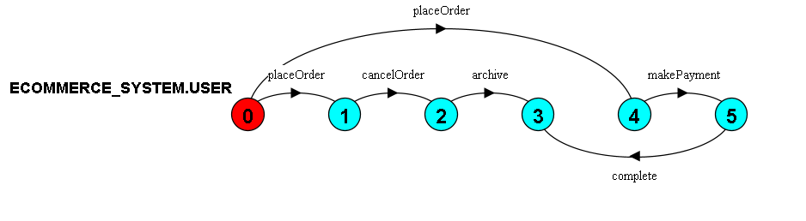
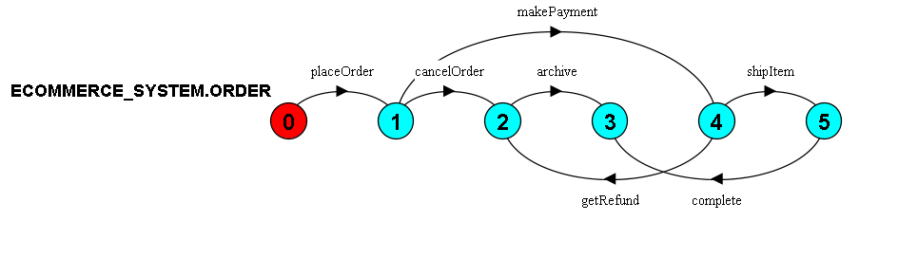
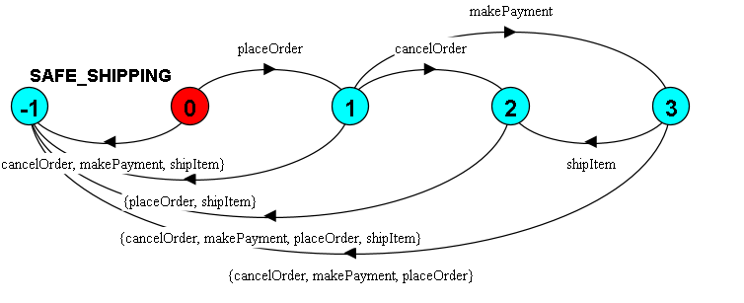

Product Model
PRODUCT = (createProduct -> STOCK_CHECK),
STOCK_CHECK = (
setStockPositive -> IN_STOCK
| setStockZero -> OUT_OF_STOCK
),
IN_STOCK = (
purchase -> STOCK_CHECK
| updatePrice -> IN_STOCK
| editInfo -> IN_STOCK
| deleteProduct -> STOP
),
OUT_OF_STOCK = (
restock -> IN_STOCK
| updatePrice -> OUT_OF_STOCK
| editInfo -> OUT_OF_STOCK
| deleteProduct -> STOP
).

||PRODUCT_SYSTEM = (PRODUCT).

Output:

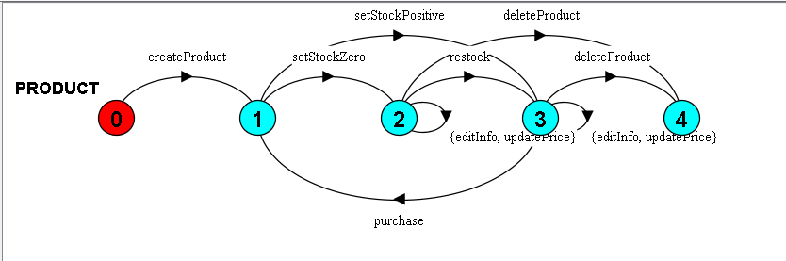

User Model
USER = (register -> HASH_MIDDLEWARE),
HASH_MIDDLEWARE = (
genSalt -> hashPassword -> save -> REGISTERED
),

REGISTERED = (
loginAttempt -> COMPARE_PASSWORD
| changePassword -> HASH_MIDDLEWARE
| updateProfile -> save -> REGISTERED
| deleteUser -> STOP
),

// Models the matchPassword method
COMPARE_PASSWORD = (
passwordMatch -> AUTHENTICATED
| passwordMismatch -> REGISTERED
),

AUTHENTICATED = (
logout -> REGISTERED
| changePassword -> HASH_MIDDLEWARE
).

||USER_SYSTEM = (USER).

Output:

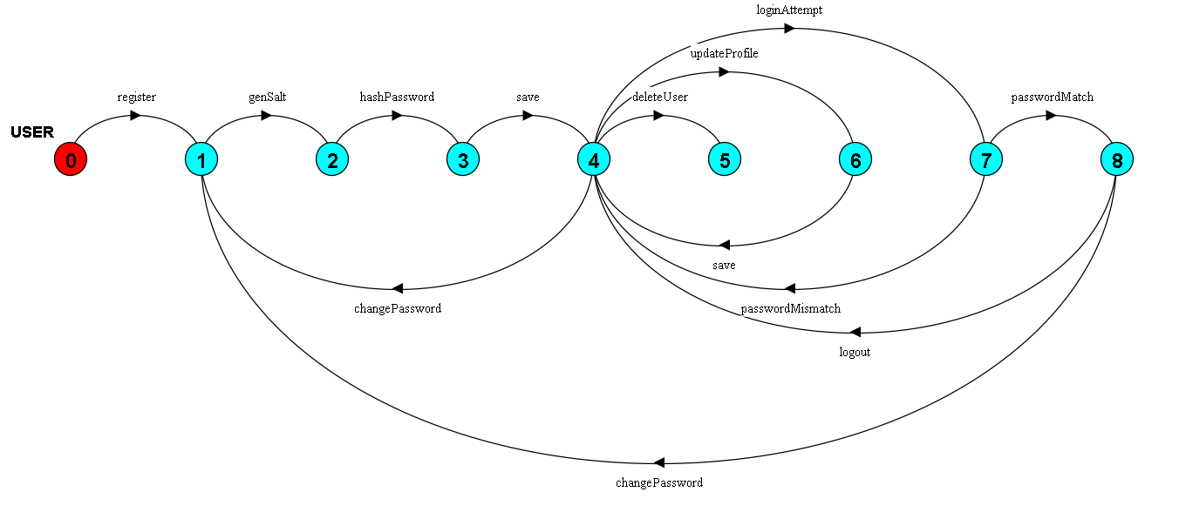
Manage Order Model:
ROUTER = IDLE,
IDLE = (
req_createOrder -> PROTECT_MW[1]
| req_myOrders -> PROTECT_MW[2]
| req_getById -> PROTECT_MW[3]
| req_getAll -> PROTECT_MW[4]
| req_markDelivered -> PROTECT_MW[5]
),

PROTECT_MW[routeId:1..5] = (
check_token_valid -> ROUTE_HANDLER[routeId]
| check_token_invalid -> error_401 -> IDLE
),

ROUTE_HANDLER[1] = (
validate_items -> (success_201 -> IDLE | error_400 -> IDLE)
),
ROUTE_HANDLER[2] = (
fetch_db_user_orders -> success_json -> IDLE
),
ROUTE_HANDLER[3] = (
fetch_db_order -> CHECK_ACCESS
),
ROUTE_HANDLER[4] = (
check_admin -> (is_admin -> fetch_all_db -> success_json -> IDLE | not_admin -> error_401 -> IDLE)
),
ROUTE_HANDLER[5] = (
check_admin -> (is_admin -> update_db_delivered -> success_json -> IDLE | not_admin -> error_401 -> IDLE)
),

CHECK_ACCESS = (
is_admin -> success_json -> IDLE
| is_owner -> success_json -> IDLE
| not_owner_not_admin -> error_401 -> IDLE
).

REGULAR_USER = (
req_createOrder -> check_token_valid -> validate_items -> success_201 -> REGULAR_USER
| req_myOrders -> check_token_valid -> fetch_db_user_orders -> success_json -> REGULAR_USER
| req_getById -> check_token_valid -> fetch_db_order -> is_owner -> success_json -> REGULAR_USER
| req_getAll -> check_token_valid -> check_admin -> not_admin -> error_401 -> REGULAR_USER
| req_markDelivered -> check_token_valid -> check_admin -> not_admin -> error_401 -> REGULAR_USER
).

ADMIN_USER = (
req_getAll -> check_token_valid -> check_admin -> is_admin -> fetch_all_db -> success_json -> ADMIN_USER
| req_markDelivered -> check_token_valid -> check_admin -> is_admin -> update_db_delivered -> success_json -> ADMIN_USER
).

||SYSTEM = (REGULAR_USER || ADMIN_USER || ROUTER).

property SECURE_DELIVERY = (
req_markDelivered -> check_token_valid -> check_admin ->
(is_admin -> update_db_delivered -> SECURE_DELIVERY
| not_admin -> error_401 -> SECURE_DELIVERY)
).

||TEST_SECURITY = (SYSTEM || SECURE_DELIVERY).

Output:
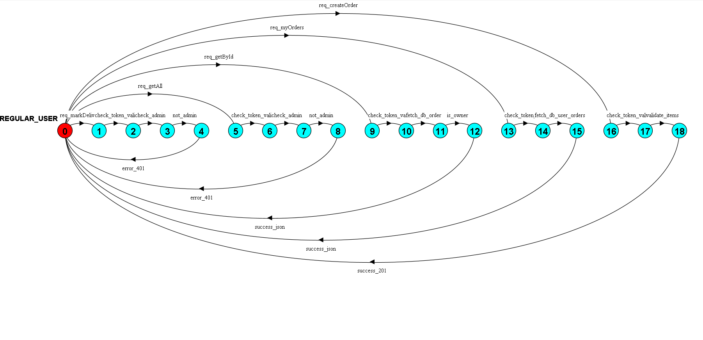
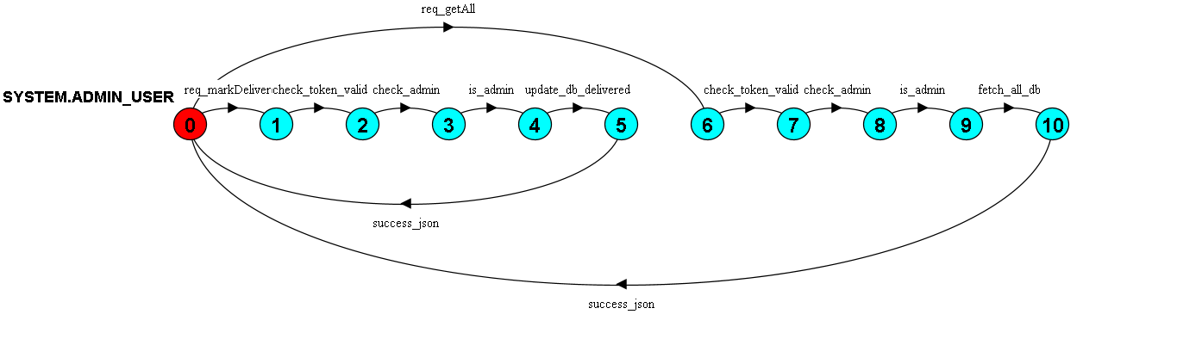
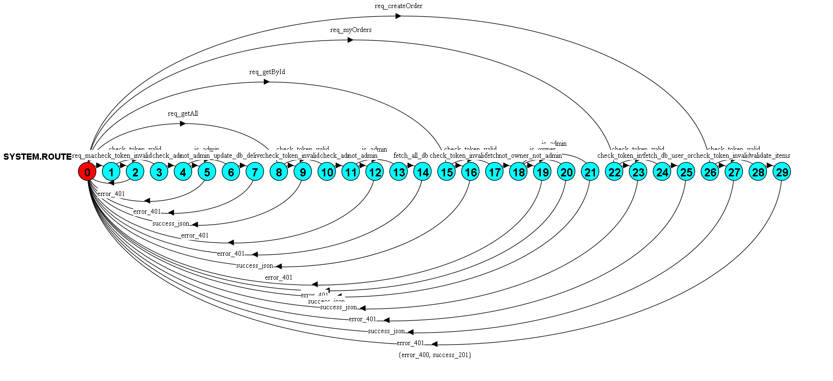
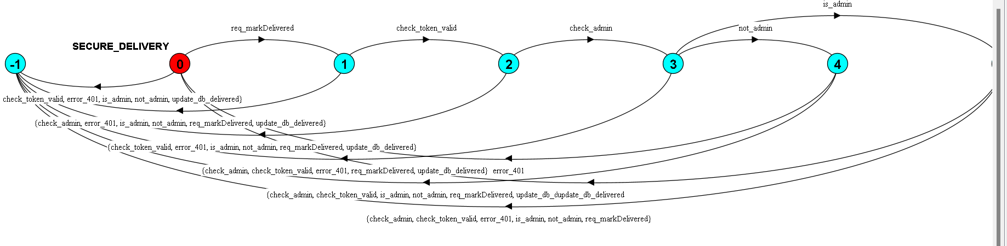
Junit Test
Code:
Order System:
package OrderSystem;
import org.junit.jupiter.api.Test;
import static org.junit.jupiter.api.Assertions.*;

public class OrderProcessorTest {

private final OrderProcessor processor = new OrderProcessor();

@Test
void testCalculateItemTotal() {
// Price: 100, Qty: 2 -> Total should be 200
assertEquals(200.0, processor.calculateItemTotal(100, 2));

// Price: 50, Qty: 0 -> Total should be 0
assertEquals(0.0, processor.calculateItemTotal(50, 0));
}

@Test
void testAddressValidation() {
// Valid address
assertTrue(processor.isAddressValid("Dhaka", "Road 12"));

// Invalid address (Missing city)
assertFalse(processor.isAddressValid("", "Road 12"));
}

@Test
void testCheckStock() {
// Stock available
assertTrue(processor.checkStock(5, 10));

// Stock not available
assertFalse(processor.checkStock(15, 10));
}

// Testing Exception (Matching the 'divide by zero' logic)
@Test
void testShipUnpaidOrder() {
IllegalStateException exception = assertThrows(
IllegalStateException.class,
() -> processor.shipOrder(false) // Sending false (Unpaid)
);

assertEquals("Cannot ship unpaid order.", exception.getMessage());
}

@Test
void testShipPaidOrder() {
// Sending true (Paid) -> Should return success message
assertEquals("Order Shipped", processor.shipOrder(true));
}
}

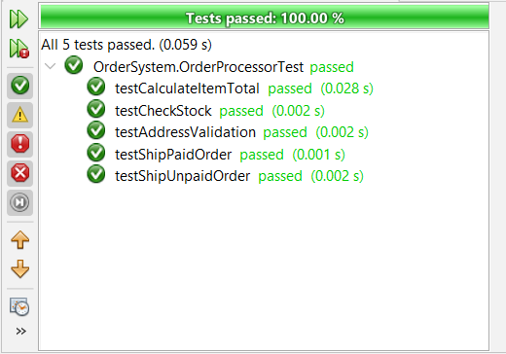

Product Manager:
package ProductSystem;

import org.junit.jupiter.api.Test;
import static org.junit.jupiter.api.Assertions.*;
import java.util.Arrays;
import java.util.List;

public class ProductManagerTest {

private final ProductManager productManager = new ProductManager();

@Test
void testIsStockAvailable() {
assertTrue(productManager.isStockAvailable(10, 5));
assertFalse(productManager.isStockAvailable(5, 10));
}

@Test
void testCalculateSavings() {
assertEquals(50.0, productManager.calculateSavings(150.0, 200.0));
assertEquals(0.0, productManager.calculateSavings(200.0, 200.0));
}

@Test
void testValidatePrice() {
IllegalArgumentException exception = assertThrows(
IllegalArgumentException.class,
() -> productManager.validatePrice(-10.0)
);
assertEquals("Price cannot be negative.", exception.getMessage());
}

@Test
void testHasColorVariant() {
List<String> colors = Arrays.asList("Red", "Blue", "Black");

assertTrue(productManager.hasColorVariant(colors, "Blue"));
assertFalse(productManager.hasColorVariant(colors, "Green"));
}
}
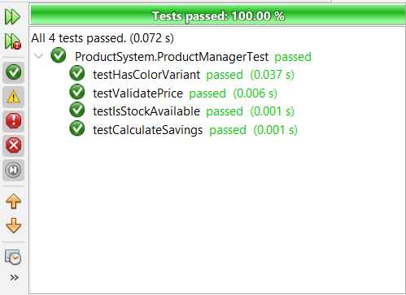
User Test:
Code:
package UserSystem;

import org.junit.jupiter.api.Test;
import static org.junit.jupiter.api.Assertions.*;

public class UserManagerTest {

private final UserManager userManager = new UserManager();

@Test
void testMatchPassword() {
assertTrue(userManager.matchPassword("secret123", "secret123"));
assertFalse(userManager.matchPassword("wrongpass", "secret123"));
}

@Test
void testIsAdmin() {
assertTrue(userManager.isAdmin(true));
assertFalse(userManager.isAdmin(false));
}

@Test
void testValidateUserSuccess() {
assertDoesNotThrow(() -> userManager.validateUser("John", "john@test.com", "123456"));
}

@Test
void testValidateUserInvalidEmail() {
IllegalArgumentException exception = assertThrows(
IllegalArgumentException.class,
() -> userManager.validateUser("John", "johntest.com", "123456")
);
assertEquals("Invalid email format", exception.getMessage());
}

@Test
void testValidateUserShortPassword() {
IllegalArgumentException exception = assertThrows(
IllegalArgumentException.class,
() -> userManager.validateUser("John", "john@test.com", "123")
);
assertEquals("Password must be at least 6 characters", exception.getMessage());
}
}
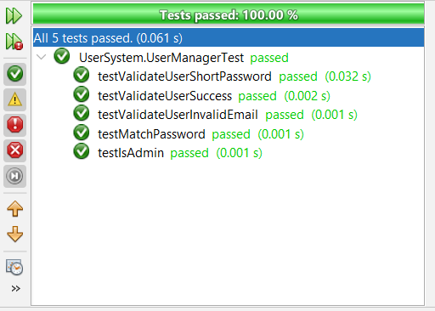
Selenium Test
